Creating an Amazon CloudFront Distribution

Alen Ovalles

Purpose

The purpose of this lesson is to apply the current knowledge of lesson two about Amazon Simple Storage Service (Amazon S3) and introduce Amazon CloudFront. The lesson will deliver content and how to decrease end-user latency using Amazon CloudFront

Process with Pictures

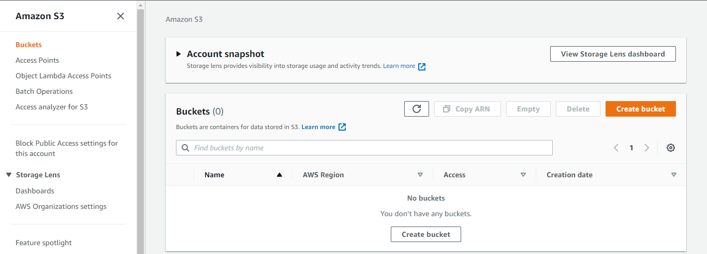

**Step 1:** Navigate to the Amazon S3 tab through the Management Console Search Bar

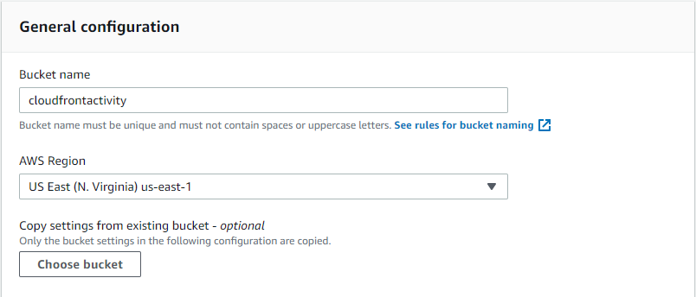

**Step 2:** Click create bucket button; Bucket name: *Select any creative name* |

AWS Region: US East (N. Virginia) us-east-1

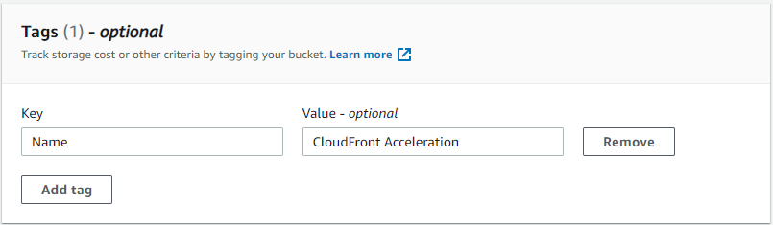

**Step 3:** Add new tag; Key: Name | Value: CloudFront Acceleration | Create the bucket

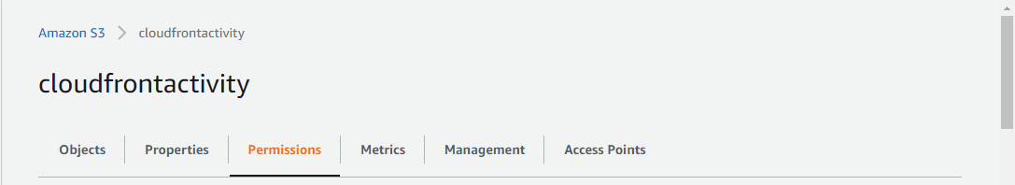

**Step 4:** Navigate to the Permissions tab after clicking the bucket name

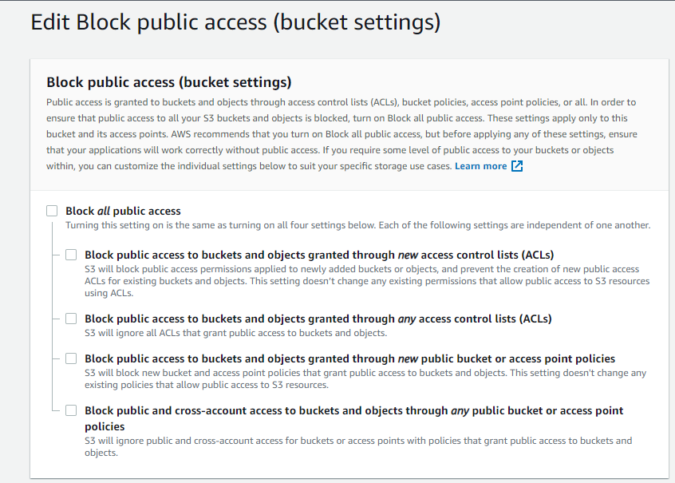**Step 5:** Deselect all the boxes shown and save

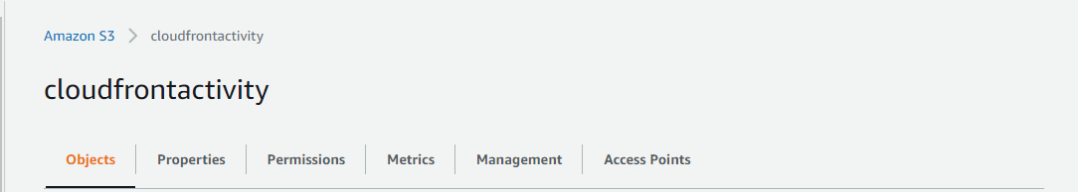

**Step 6:** Navigate to the Objects tab and click the Upload button

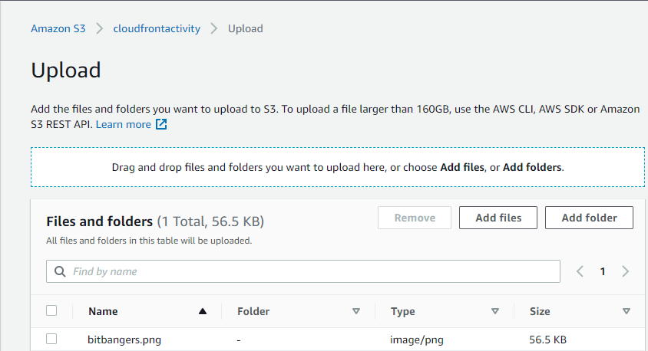

**Step 7:** Add the bitbangers.png file used in lesson two

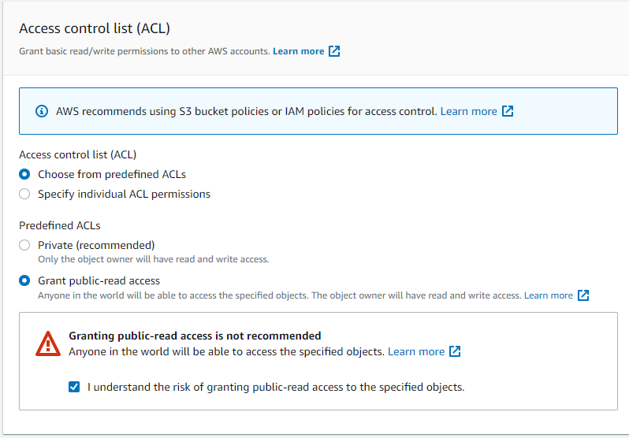

**Step 8:** In the Access control list (ACL) tab choose Grant public-read access and click the checkmark for understanding, then create

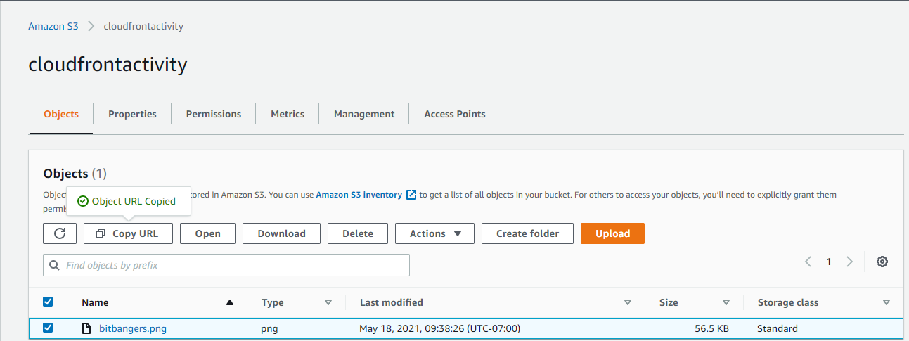

**Step 9:** Highlight create upload file and copy URL

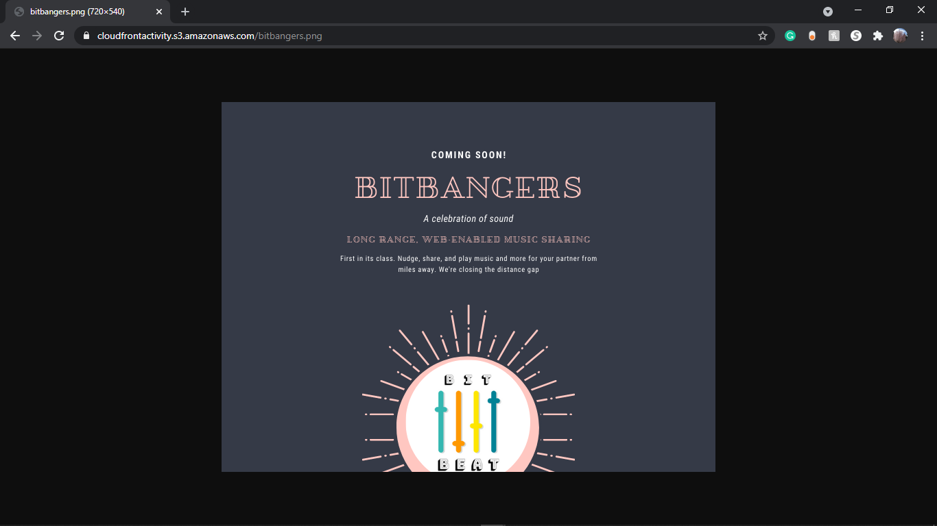

**Step 10:** Paste copied URL into a new browser

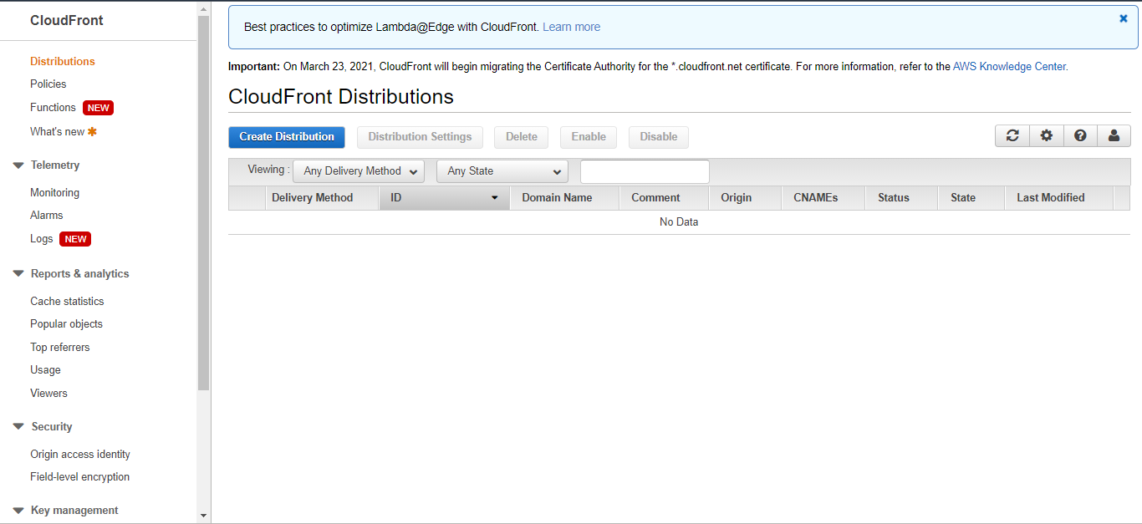

**Step 11:** Navigate to the CloudFront Distributions services under Network and Content Delivery category

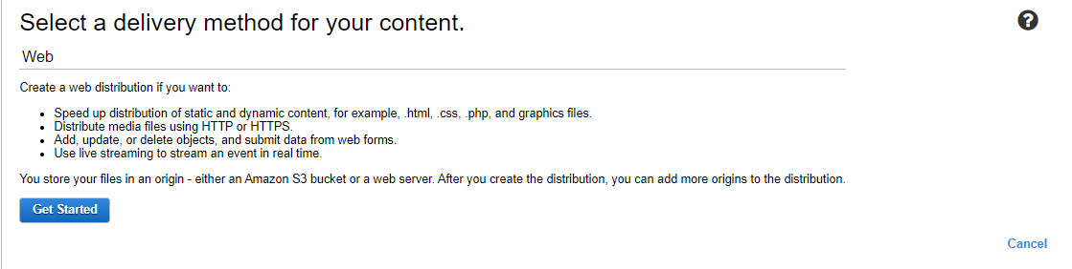

**Step 12:** Select the correct delivery method of web and click Get Started

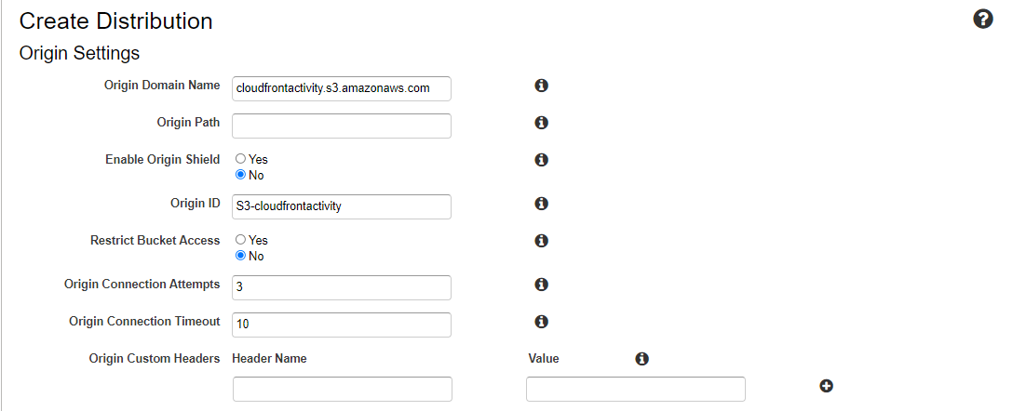

**Step 13:** Match the Origin Domain Name with the created Amazon S3 bucket

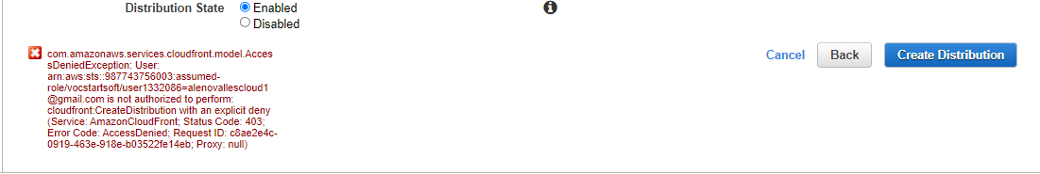

**Step 14:** Click the Create Distribution button in the bottom right

Problems

There is a significant problem with proceeding through this lab. Shown above in the bottom left and below are screenshots of errors that Amazon points out. The errors are about how the aws starter account that is being used for this lesson does not have the authority to use the CloudFront service and doesn’t have the authority to create the distribution. This is probably an account access problem with the user having no control in changing authority or overriding authority to allow access to CloudFront. Due to this problem/error/block, I had to stop at this point in the lesson and end there.

